# CS 255 System Design Document – Kyunghoon Lee

This template lays out all the different sections that you need to complete for Project Two. Each section has guidance to prompt your thinking. You will need to continually reference the interview transcript as you work to make sure that you are addressing your client’s needs. There is no required length for the final document. Instead the goal is to complete each section based on what your client’s needs are. Remove this note when you are finished, and replace all bracketed text with the relevant information.

## UML Diagrams

### UML Use Case Diagram

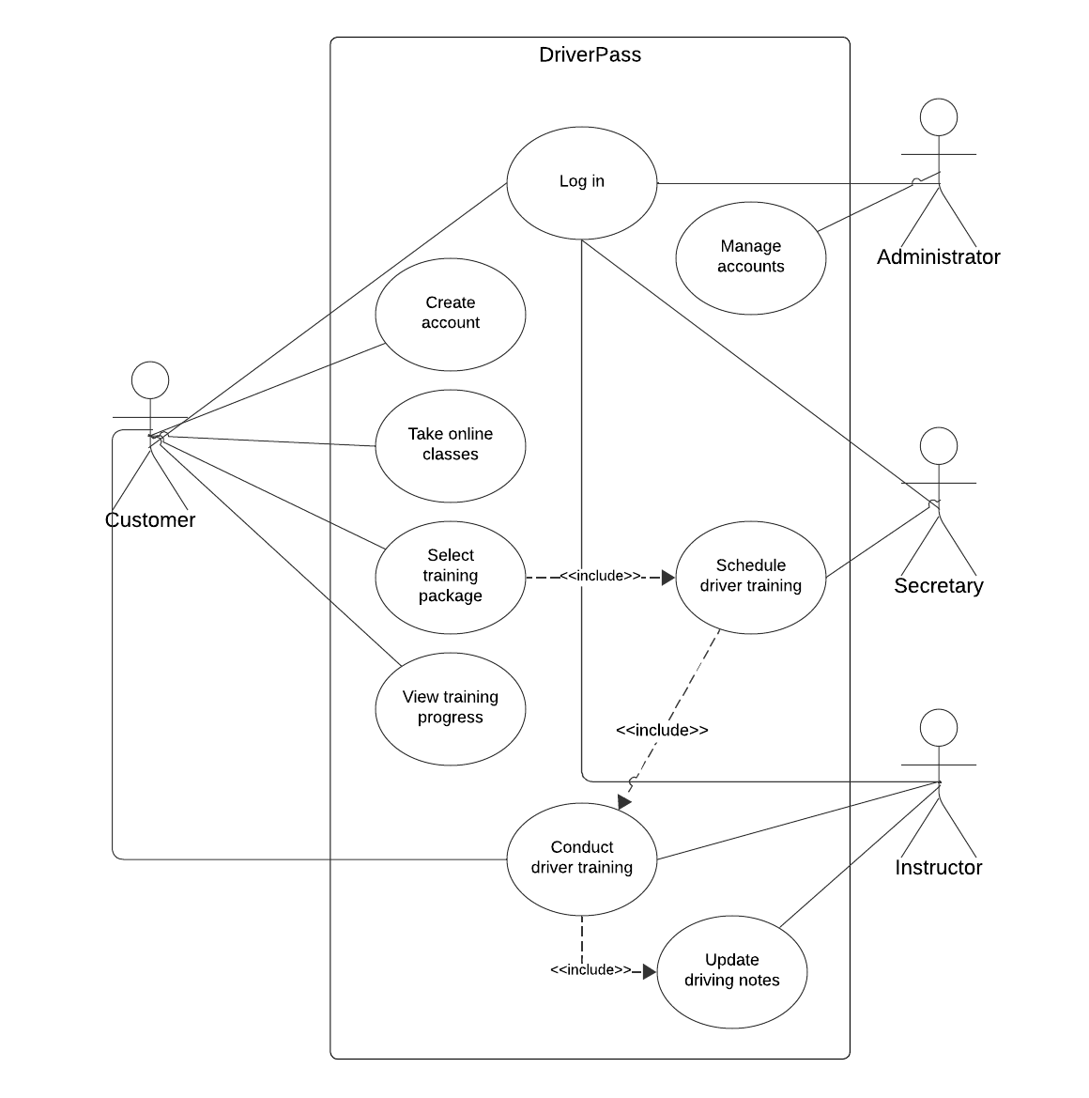

### UML Activity Diagrams

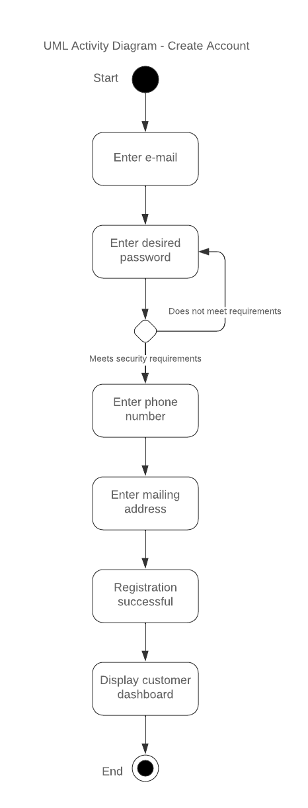

### UML Sequence Diagram

### UML Class Diagram

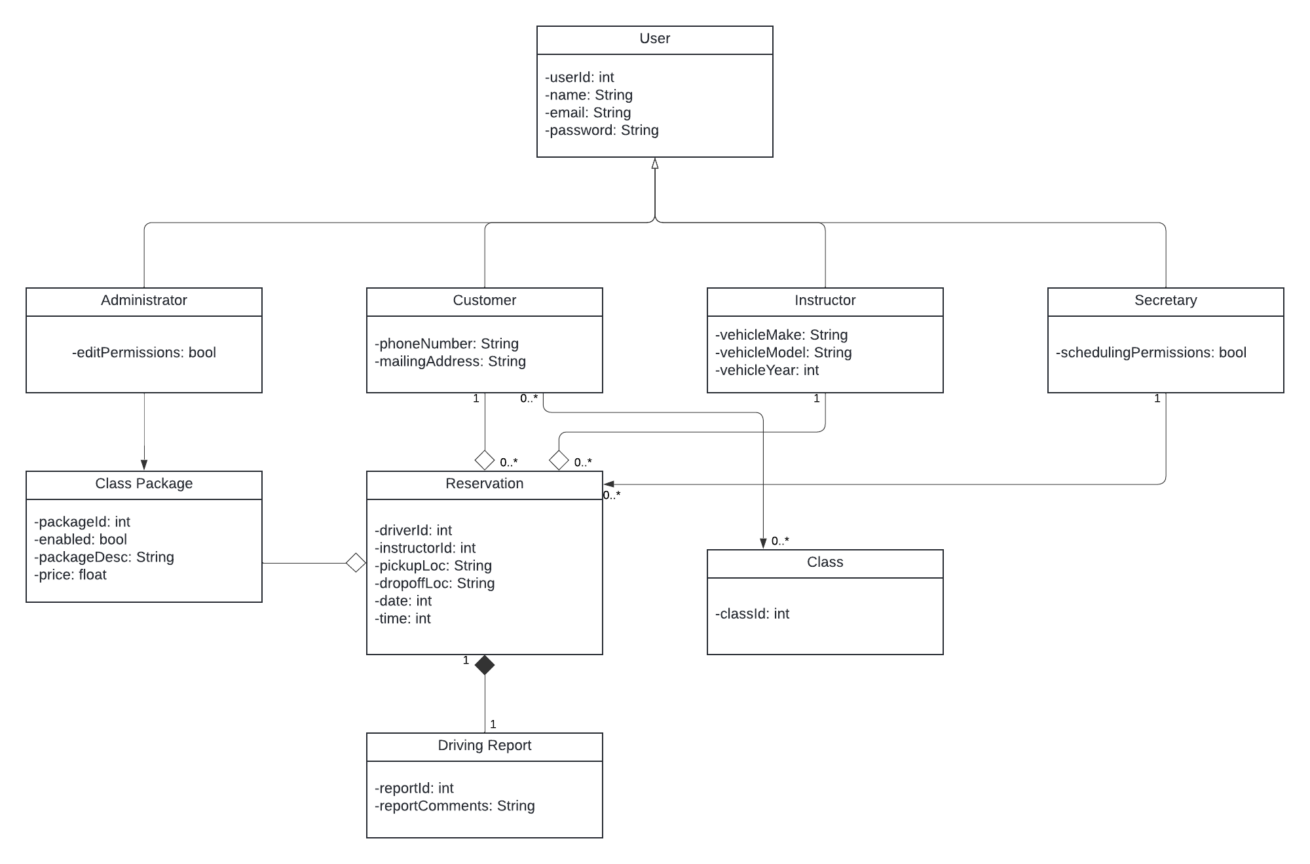

## Technical Requirements

*[Based on the diagrams you have created, describe the technical requirements of your system. These requirements should address the required hardware, software, tools, and infrastructure necessary for your system design.]*

Hardware Requirements:

* Physical server for application hosting and storage
* Networking interface to connect host server to internet
* Input devices for interaction with host (keyboard, monitor, mouse)
* Client devices (smartphone, desktop/laptop computers, tablets)

Software Requirements:

* Host server operating system of choice (Windows/Linux/MacOS)
* Database for storing information (SQL Server, PostgreSQL, MySQL)
* Completed DriverPass application
* Backup control software
* Security software
* IDE of choice (VSCode, Eclipse)
* Web browser of choice (Chrome, Safari, Firefox)

Infrastructure Requirements:

* Stable broadband internet connection
* Offsite storage for backups
* Cloud provider for backup storage